Software Requirement Specifications
NetGuard AI
An AI-Powered Network Intrusion Detection and Automated Mitigation Framework



Submitted by
Shahanzeb Khan (S23BINFT1M01053)
Submitted to
Ma’am Kainat

Department of Information Technology
Faculty of Computing
The Islamia University of Bahawalpur
Summary:
NetGuard AI is a network security system that detects and responds to threats on its own, without waiting for an analyst to catch something on a dashboard and escalate it. The idea is straightforward: most network attacks do their damage during the window between detection and human response. NetGuard is built to close that window.
When the system detects suspicious traffic, it runs it through a machine learning model that classifies it as either a DDoS attack or a data exfiltration attempt. If the confidence crosses the threshold, it doesn't just log the event it immediately pushes Access Control List rules to the affected Cisco routers over SSH, blocking the malicious IPs before the attack can progress further. The whole process happens automatically, in real time, without anyone having to intervene.
Administrators and security teams get a web-based dashboard built in React.js that shows live packet traffic, AI-generated threat classifications, and a full log of every mitigation action the system has taken what was blocked, when, and why. It's designed to give SOC analysts and network engineers’ full visibility into what the system is doing, even when they're not actively watching it.
On the backend, Python Flask handles the core application logic and API layer, while Netmiko manages the SSH connections to Cisco routers and handles the actual configuration pushes. All threat data, traffic logs, and mitigation records are stored in MySQL, giving teams a reliable audit trail they can query and review.
The project is being developed using a prototyping approach, which means the detection and response logic is built and validated in stages. Rather than designing the entire system upfront and hoping it works, each component the packet sniffer, the ML classifier, the automation layer — gets tested independently before being integrated. This keeps the development grounded and makes it easier to catch issues early, especially in the parts of the system where accuracy matters most.
The broader goal is to reduce the operational burden on security teams who currently rely on round-the-clock manual monitoring. In large enterprise environments, that kind of oversight is expensive and hard to sustain. NetGuard is designed to handle the immediate response layer automatically, so analysts can focus on investigation and strategy rather than firefighting every alert that comes in.

Table of Contents
1 Introduction 4
1.1 Purpose 4
1.2 Scope 4
1.3 Product Perspective 5
1.4 User Characteristics 5
1.5 Similar apps and system/Literature Review 5
1.6 Proposed Technologies 5
2. Requirements 6
2.1 Functional Requirements 6
2.1.1 Sign up 6
2.2 Non-Functional Requirements 6
3. Use Cases and Flow of processes 7
3.1 Use Case 1: 9
3.2 Use Case 2: 9
3.3 Use Case 3: 10
3.4 Activity Diagram: 10
4. Reference 12

Introduction
NetGuard AI sits between network monitoring and active threat response it doesn't just watch traffic, it does something about it. Administrators can register on the platform, view live network telemetry, and let the system handle threats autonomously when they're detected.
The problem it's solving is pretty specific: when a breach is actively happening, manual response is too slow. Someone has to notice, escalate, decide, and act. By the time that chain completes, damage is already done. NetGuard cuts that process out for the response layer, handling mitigation automatically so organizational data and uptime don't depend on whether the right person is available at the right moment.
The AI and network automation components aren't bolted on as extras they're what make the whole thing work. Machine learning handles the classification, automation handles the router configurations, and together they make a response system that's fast enough to actually matter during a live attack. The goal isn't to replace security teams but to give them a system that handles the immediate, time-critical layer so they can focus on everything else.

Purpose
To design a secure and autonomous online platform that connects AI-driven detection with network infrastructure for effective intrusion mitigation and the improvement of organizational cyber security.

Scope
The project covers three main areas.
User Registration and Authentication: Only authorized administrators and security analysts can access the system. Login is handled securely, making sure the platform isn't open to anyone who shouldn't be touching it.
Automated Mitigation System: This is the core of what NetGuard does. Traffic gets analyzed in real time, and when a threat is confirmed, security policies are pushed directly to the routers without waiting for manual approval. The response happens at machine speed, not human speed.
Data Management and Reporting: Every detected threat, blocked IP, and network event gets logged. Security teams can look back at what happened, when it happened, and what the system did about it which matters both for audits and for understanding patterns over time.

Product Perspective
NetGuard AI is a standalone security application that streamlines the detection-to-mitigation workflow. It involves administrator registration, profile management, real-time threat matching, automated alerts, and an executive security dashboard.

User Characteristics
- Security Analysts are the main people using NetGuard day-to-day. Their job is to keep an eye on network health and dig into alerts when something looks off. They already understand network protocols and security fundamentals, so they don't need basic explanations they need a tool that keeps up with them.
- Network Administrators handle the infrastructure behind the scenes. They manage router configurations, maintain the automation logic, and make sure NetGuard stays properly connected to the network components it depends on. When something in the system pipeline needs fixing or updating, that falls on them.

Similar apps and system/Literature Review
- Snort IDS is a well-known open-source option that does a decent job detecting threats. The catch is that it relies heavily on manual rule updates and needs external scripts to actually do anything about what it finds. Detection without built-in response means someone still has to step in.
- Cisco Firepower is the enterprise-grade choice deep packet inspection, solid features and reliable performance. But it comes with a price tag to match. The hardware is dedicated and expensive, and the licensing costs put it out of reach for a lot of organizations that don't have that kind of budget.
- Suricata handles real-time detection and prevention well and gives good visibility into what's happening on the network. Where it falls short is automation. It doesn't have the custom Python-driven self-healing logic needed to work inside a virtualized GNS3 environment, which is exactly the gap NetGuard is designed to fill.

Proposed Technologies
- Platform: Web-based application accessible via desktop management consoles.
- Technology Stack:
  - Frontend: React.js, HTML, CSS, JavaScript.
  - Backend: Python, Flask, Netmiko, Pyshark.
  - Database: MySQL for incident logging and user data.
- Security: Implementation of SSL encryption, secure SSHv2 protocols for router access, and multi-factor authentication for admins.

2. Requirements

2.1 Functional Requirements
- Admin Registration:
- User Profile: Provide functionality for creating an admin profile including name, role, and assigned network sector.
- AI Security Chatbot:
- Chatbot: Include an AI-driven chatbot to assist admins with common security queries, protocol definitions, and mitigation steps.
- Threat Mitigation Engine:
- ML Classification: Real-time classification of traffic as "Normal" or "Malicious" based on the NSL-KDD dataset.
- Automated Mitigation: Automated SSH login to GNS3 routers to apply ACLs upon threat detection.
- Real-time Alerts: Immediate visual and logged alerts when a threat is neutralized.
- Traffic Monitor:
- Live Sniffing: Visualization of captured packet headers and protocol distribution.
- Map/Topology Integration: Displaying the virtual network map and highlighting nodes under attack.

2.1.1 Sign up

- Full name.
- Employee ID/Contact.
- Admin Role.
- Network Sector/Location.

2.2 Non-Functional Requirements
Backup: Security logs and the database get backed up every day. Losing threat history or mitigation records isn't an option, so this runs automatically without anyone having to remember to do it.
Security: All data moving through the system is encrypted over SSL. Router automation runs exclusively over SSHv2 with key-based authentication, so there's no weak link in how NetGuard talks to the network infrastructure.
Usability: The dashboard is designed to be clean and professional without being cluttered. It's also optimized to run smoothly on machines with 8GB RAM, so analysts aren't dealing with a sluggish interface when they need information fast.
Maintainability: The Python automation code is written in a modular structure with proper documentation throughout. When something needs to be updated or extended down the line, the next developer shouldn't have to reverse-engineer what the previous one was thinking.
Compatibility: The system works on Chrome, Firefox, and Safari across desktop devices, covering the browsers most administrators and analysts are already using.

3. Use Cases and Flow of processes
Use cases are the formal representation of process flow defined by functional requirements. Below is a use case diagram for a NetGuard AI (An AI-Powered Network Intrusion Detection and Automated Mitigation Framework)
The diagram includes primary actors (Security Analyst and Network Admin) and the main use cases of the system.

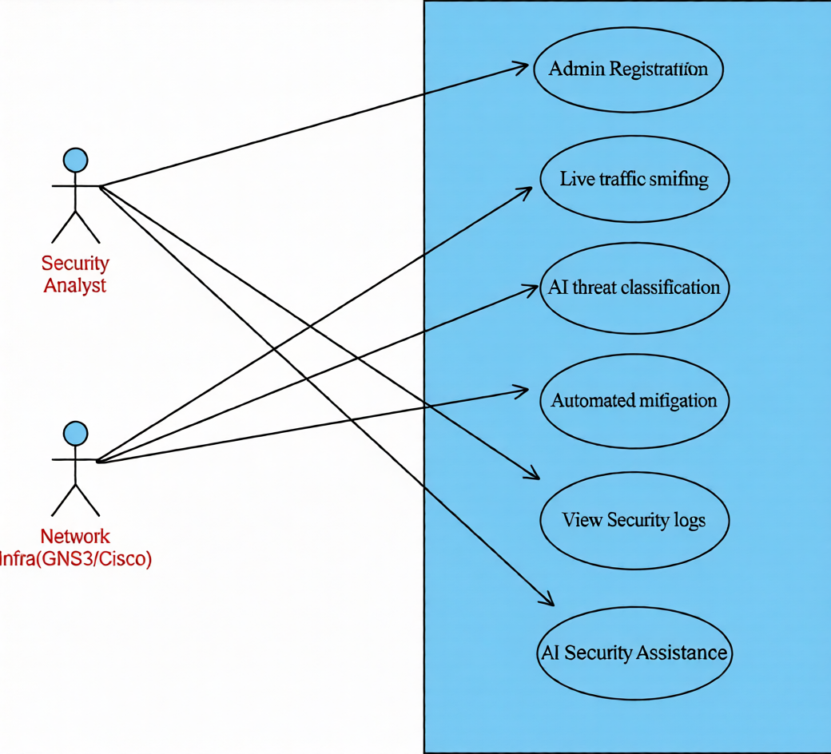

Figure 1: System Level Use Case Diagram

3.1 Use Case 1:
Admin Registration & Monitoring

ID | UC001
Name | Sign Up/Register Admin (Monitoring Functionality)
Description | Describes the admin onboarding and initial dashboard access.
Actors | Network Admin, Security Analyst
Flow | 1. Admin creates profile.  2. System validates credentials.  3. Dashboard displays live GNS3 traffic.

3.2 Use Case 2:
Threat Detection & Classification
ID | UC002
Name | ML Classifier Engine
Description | Describes the AI analysis of incoming network packets.
Actors | NetGuard AI System (Backend)
Flow | 1. System sniffs traffic via Pyshark.  2. ML model predicts traffic type.  3. Results sent to dashboard.

3.3 Use Case 3:
Automated Mitigation
ID | UC003
Name | Automated Response Module
Description | Describes the process of blocking an attacker.
Actors | Netmiko Controller, Cisco Virtual Router
Flow | 1. System identifies malicious IP.  2. Netmiko logs into router.  3. ACL is applied to block IP.

3.4 Activity Diagram:
The Activity Diagram walks through exactly what happens from the moment NetGuard starts watching the network to the moment it blocks a threat.
Start Monitoring: The backend controller initializes and starts listening on the designated network interface. From this point, the system is live.
Packet Capture: Pyshark pulls live packets directly from the GNS3 virtual environment. Nothing is sampled or delayed it's capturing as traffic moves.
Pre-processing: The system extracts relevant features from packet headers and structures them in a format the AI model can work with. Raw packets aren't useful on their own; this step turns them into something meaningful.
AI Classification: A Random Forest model takes those features and makes a call: is this traffic Normal or Malicious? The model is trained on the NSL-KDD dataset, which gives it a solid baseline for recognizing attack patterns.
Decision: If the traffic looks clean, the system moves on and keeps monitoring. If it's flagged as malicious, the system identifies the source IP and kicks off the mitigation workflow.
Log and Alert: The threat details get written to the MySQL database and a real-time notification is pushed to the React dashboard. The security team sees what happened, when, and where it came from.
Automated Block: Netmiko SSHs into the virtual Cisco router and applies an ACL rule that drops all further traffic from the attacker's IP. No manual steps, no delay.
Loop: The process starts over and keeps running. There's no off switch the system monitors continuously, around the clock, without needing anyone to restart it.
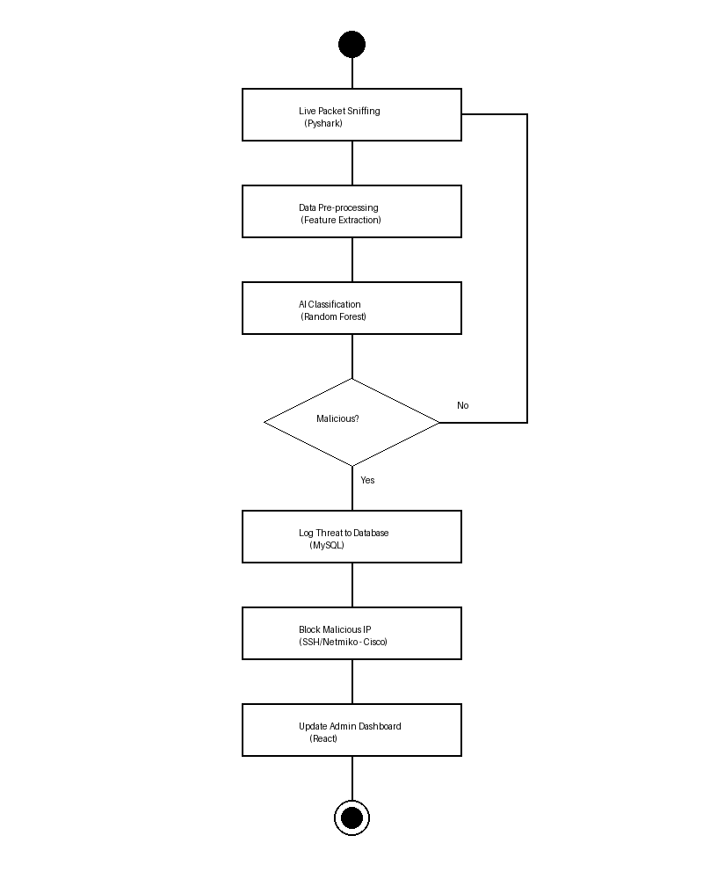

Figure 2: NetGuard AI System Activity Diagram

4. Reference

Flask Documentation:
Flask. (2024). Flask Documentation. Retrieved from https://flask.palletsprojects.com/
This is the official documentation for Flask, a Python-based micro-web framework that will be used for the back-end API development and handling system requests.
React Documentation:
React. (2024). React – A JavaScript library for building user interfaces. Retrieved from https://react.dev/
React is a JavaScript library for building the front-end dashboard components and real-time security telemetry visualization for the project.
Scikit-learn Documentation:
Scikit-learn. (2024). Scikit-learn: Machine Learning in Python. Retrieved from https://scikit-learn.org/
Scikit-learn will be used to implement the Machine Learning algorithms, such as Random Forest, to classify network traffic into normal or malicious categories.
Netmiko Documentation:
Byers, K. (2024). Netmiko Documentation. Retrieved from https://ktbyers.github.io/netmiko/
Netmiko is a multi-vendor library that simplifies SSH connections to network devices; it will be used for automated ACL deployment on Cisco routers during mitigation.
GNS3 Documentation:
GNS3. (2024). GNS3 Documentation. Retrieved from https://docs.gns3.com/
GNS3 is the network simulation platform used to create and test the virtual network topology, providing the environment for the NIDS to operate.
MySQL Documentation:
MySQL. (2024). MySQL Reference Manual. Retrieved from https://dev.mysql.com/doc/
MySQL will be used as the relational database for storing administrative credentials, threat logs, and the history of automated security actions.
Pyshark Documentation:
Kimi, D. (2024). Pyshark: Python wrapper for tshark. Retrieved from https://github.com/KimiNewt/pyshark
Pyshark will be used for real-time packet sniffing and extracting features from live network traffic to feed into the AI classifier.

